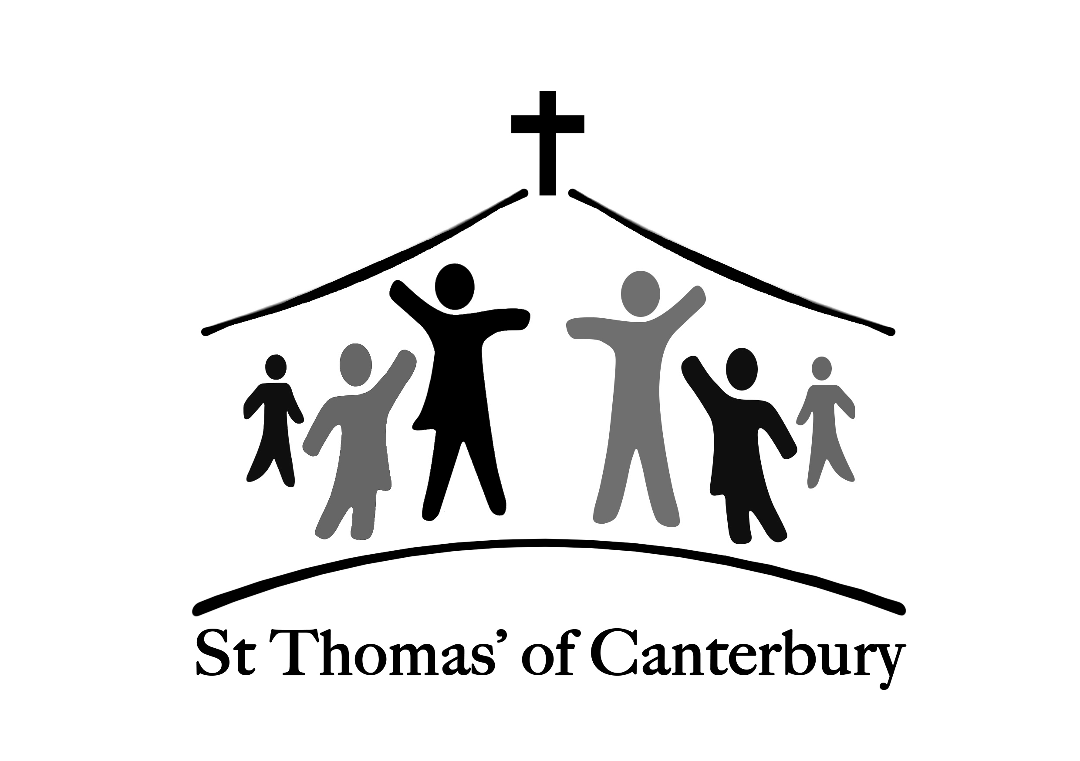St Thomas of Canterbury Wilbury Letchworth Garden City
Sunday worship for the
Easter season

Welcome to our Sunday worship for the Easter season, the period of time between Easter and Pentecost when followers encountered the resurrected Jesus. We celebrate hope! as death could not hold Jesus - Christ is risen, Alleluia.
If you are joining us for the first time today we welcome you. To follow, is a service of Holy Communion. As we gather to worship and praise God together, may you be blessed beyond measure.

Welcome – we greet each other in the Lord’s name
Hymn
Minister In the name of the Father, and of the Son, and of the Holy Spirit.
All Amen

Minister Alleluia. Christ is risen!
All He is risen indeed. Alleluia!

A sentence of scripture may be read
Preparation – we prepare our hearts to worship
All Almighty God, to whom all hearts are open.
all desires known,
and from whom no secrets are hidden:
cleanse the thoughts of our hearts
by the inspiration of your Holy Spirit,
that we may perfectly love you,
and worthily magnify your holy name;
through Jesus Christ our Lord. Amen.

Prayer of Penitence – we confess our sins and are assured of God’s forgiveness

Minister Our Lord Jesus Christ said:
The first commandment is this:
‘Hear, O Israel, the Lord our God is the only Lord.
You shall love the Lord your God
with all your heart, with all your soul, with all your mind, and with all your strength.’
The second is this:
‘Love your neighbour as yourself.’
There is no other commandment greater than these.

Minister Christ our Passover Lamb has been sacrificed for us.
Let us therefore rejoice by putting away all malice and evil and confessing our sins with a sincere and true heart.

All Most merciful God, Father of our Lord Jesus Christ, we confess that we have sinned in thought, word, and deed.
We have not loved you with our whole heart. We have not loved our neighbours as ourselves.
In your mercy forgive what we have been, help us to amend what we are,
and direct what we shall be;
that we may do justly, love mercy,
and walk humbly with you, our God. Amen.

Kyrie Eleison – we pray for God's mercy and the grace to give us what we need for faithful discipleship
Minister Lord, have mercy.
All Lord, have mercy.
Minister Christ, have mercy.
All Christ, have mercy.
Minister Lord, have mercy.
All Lord, have mercy.

Minister offers words of forgiveness

Gloria in Excelsis – in response to God’s grace and mercy, we share in the words of the gloria
All Glory to God in the highest,
and peace to his people on earth.
Lord God, heavenly King,
almighty God and Father,
we worship you, we give you thanks,
we praise you for your glory.
Lord Jesus Christ, only Son of the
Father,
Lord God, Lamb of God,
you take away the sin of the world:
have mercy on us;
you are seated at the right hand of the
Father: receive our prayer.
For you alone are the Holy One,
you alone are the Lord,
you alone are the Most High, Jesus
Christ,
with the Holy Spirit,
in the glory of God the Father.
Amen.

The Collect – we keep silence as the minister prays the Collect, the prayer of the day

The Ministry of the Word – we proclaim and respond to the word of God

We will hear from the bible and at the end the reader will say ‘This is the word of the Lord’ and we will respond ‘Thanks be to God’.

Hymn

Minister Alleluia, alleluia.
I am the first and the last, says the Lord, and the living one;
I was dead, and behold, I am alive for evermore.
Hear the Gospel of our Lord Jesus Christ according to…
All Glory to you, O Lord.

At the end:
Minister This is the Gospel of Christ
All Praise to you, O Christ.

The Sermon – A short reflection on the days readings

The Nicene Creed – we affirm our faith in the words of the creed

All We believe in one God,
the Father, the almighty, maker of heaven and earth,
of all that is, seen and unseen.
We believe in one Lord, Jesus Christ,
the only Son of the Father,
God from God, Light from Light,
true God from true God, begotten, not made,
of one Being with the Father:
through him all things were made.
For us and for our salvation
he came down from heaven,
he became incarnate from the Holy Spirit and the Virgin Mary, and was made man.
For our sake he was crucified under Pontius Pilate;
he suffered death and was buried.
On the third day he rose again
in accordance with the Scriptures;
he ascended into heaven
and is seated at the right hand of the Father.
He will come again in glory
to judge the living and the dead,
and his kingdom will have no end.
We believe in the Holy Spirit, the Lord, the giver of life, who proceeds from the Father and the Son,
who with the Father and Son is worshipped and glorified, who has spoken through the prophets.
We believe in one holy, catholic and apostolic Church.
We acknowledge one baptism for the forgiveness of sins.
We look for the resurrection of the dead, and the life of the world to come. Amen.

Prayers for the Church and the world

Minister In the power of the Spirit and in union with Christ, let us pray to the Father.
Let us pray for the Church and for the world and let us thank God for his goodness.

The following response is used for each prayer:
Reader Lord, in your mercy,
All hear our prayer.

At the end:
Reader Merciful Father,
All accept these prayers for the sake of your Son, our Saviour Jesus Christ. Amen.

Exchange the Peace – we offer each other a sign of God’s peace.

Minister The risen Christ came and stood among his disciples and said, 'Peace be with you.' Then they were glad when they saw the Lord. Alleluia.
The peace of the Lord be always with you.
All and also with you.
Minister Let us offer one another a sign of Christ’s peace.

Hymn

The table is prepared and we give thanks through our
offerings and our gifts

All Yours, Lord, is the greatness, the power, the glory, the splendour, and the majesty;
For everything in heaven and on earth is yours.
All things comes from you, and of your own do we give you.

The Eucharistic Prayer

Minister The Lord is here.
All His Spirit is with us.
Minister Lift up your hearts.
All We lift them to the Lord.
Minister Let us give thanks to the Lord our God.
All It is right to give thanks and praise.

Minister You are worthy of our thanks and praise, Lord God of truth,
for by the breath of your mouth you have spoken your word,
and all things have come into being.
You fashioned us in your image
and placed us in the garden of your delight.
Though we chose the path of rebellion
you would not abandon your own.

Again and again you drew us into your covenant of grace.
You gave your people the law and taught us by your prophets
to look for your reign of justice, mercy and peace.
As we watch for the signs of your kingdom on earth, we echo the songs of the angels in heaven evermore praising you and saying:

All Holy, holy, holy Lord, God of power and might, heaven and earth are full of your glory.
Hosanna in the highest.
Blessed is he who comes in the name of the Lord.
Hosanna in the highest.

Minister Lord God, you are the most holy one,
enthroned in splendour and light, yet in the coming of your Son Jesus Christ you revealed the power of your love
made perfect in our human weakness.

All Amen. Lord, we believe.

Minister Embracing our humanity,
Jesus showed us the way of salvation;
loving us to the end, he gave himself to death for us; dying for his own, he freed us from the bonds of sin,
that we might rise and reign with him in glory.

All Amen. Lord, we believe.

Minister On the night he gave himself for us all
he took bread and gave you thanks;
he broke it and gave it to his disciples, saying:
Take, eat; this is my body which is given for you; do this in remembrance of me.

All Amen. Lord, we believe.

Minister In the same way, after supper
he took the cup and gave you thanks;
he gave it to them, saying:
Drink this, all of you; this is my blood of the new covenant, which is shed for you and for many for the forgiveness of sins.
Do this, as often as you drink it, in remembrance of me.

All Amen. Lord, we believe.

Minister Great is the mystery of faith:
All Christ has died:
Christ is risen:
Christ will come again.

Minister Therefore we proclaim the death
that he suffered on the cross,
we celebrate his resurrection, his bursting from the tomb,
we rejoice that he reigns at your right hand on high,
and we long for his coming in glory.

All Amen. Come, Lord Jesus.

Minister As we recall the one perfect sacrifice for our redemption.
Father, by your Holy Spirit, let these gifts of your creation be to us the body and blood of our Lord Jesus Christ,
form us into the likeness of Christ,
and make us a perfect offering in your sight.

All Amen. Come, Holy Spirit.

Minister Look with favour on your people
and in your mercy hear the cry of our hearts.
Bless the earth, heal the sick, let the oppressed go free, and fill your Church with power from on high.

All Amen. Come, Holy Spirit.

Minister Gather your people from the ends of the earth to feast with (N and) all your saints
at the table in your kingdom
where the new creation is brought to perfection in Jesus Christ our Lord.

All By whom, and with whom, and in whom, in the unity of the Holy Spirit, all honour and glory be yours,
Almighty Father, for ever and ever. Amen.

Minister As our Saviour taught us, so we pray
All Our Father in heaven,
hallowed be your name,
your kingdom come,
your will be done,
on earth as in heaven.
Give us today our daily bread.
Forgive us our sins
as we forgive those who sin against us.
Lead us not into temptation
but deliver us from evil.
For the kingdom, the power,
and the glory are yours
now and for ever.
Amen.

Minister We break this bread to share in the body of Christ.
All Though we are many, we are one body,
because we all share in one bread.

All Jesus, Lamb of God,
have mercy on us.
Jesus, bearer of our sins,
have mercy on us.
Jesus, redeemer of the world,
grant us peace.

Minister Alleluia. Christ our Passover is sacrificed for us.
All Therefore let us keep the feast. Alleluia.

The minister and congregation will receive
communion during which time the online
congregation are invited to pray the following prayer.

All Thanks be to you Lord Jesus Christ, for all the benefits you have given me, for all the pains and insults you have borne for me. Since I cannot receive you sacramentally, I ask you to come spiritually into my heart. O most merciful redeemer, friend and brother, may I know you more clearly, love you more dearly, and follow you more nearly day by day. Amen

Post Communion Prayer
All Gracious Lord,
in this holy sacrament
you give substance to our hope:
bring us at the last
to that fullness of life for which we long;
through Jesus Christ our Saviour.

The Blessing – we depart with God’s blessing
Minister May Christ give you grace to grow in holiness,
to deny yourselves, take up your cross, and follow him;
and the blessing of God almighty,
the Father, the Son, and the Holy Spirit,
be among you and remain with you always.
All Amen.

Hymn

The Dismissal – we are sent to live out our faith

Minister Go in the peace of Christ. Alleluia, alleluia.
All Thanks be to God. Alleluia, alleluia.
Minister May the souls of the faithful departed this day rest in peace.
All And then rise in glory. Amen

We pray for God’s blessing on you throughout this
week
– check our website or notice board for daily prayer
times in the church.

